***SRS Documentation for Online shopping portal***

***(cosmetics application)***

***Name:-E.Mokan Raam***

***Date:-7/4/2024***

***Table of Content:-***

1. **Introduction**
   1. Purpose
   2. Intended Audience
   3. Scope
2. **System features and Requirements**
   1. Functional Requirements
   2. Non Functional Requirements
   3. Flow chart
   4. Use Case diagram
   5. Sequence diagram
   6. Class Diagram
3. **TestCases**
4. **Deliver for Approval**
5. **INTRODUCTION**

The Online Shopping Platform aims to revolutionize the retail experience by providing users with attractive interface for purchasing goods and services online. This Software Requirements Specification (SRS) document depends on the functional and non-functional requirements necessary for the development of this platform.

By encrypting critical data, using safe authentication procedures, and guarding against frequent cyberattacks, the system guarantees security. Additionally, it gives accessibility first priority and offers a responsive web interface that is compatible with Featuring very user-friendly UI and flexible style across various devices and browsers.

The system's design must take into account all applicable rules, including those pertaining to data protection and payment card industry requirements.

* 1. **Purpose**

The purpose of this document is to provide a comprehensive overview of the requirements for the Online Shopping Platform. It serves as a guide for developers, designers, and stakeholders involved in the project

* 1. **Intended Audience**

This document is intended for the development team, including software engineers, designers, testers, project managers, and stakeholders involved in the development of the Online Shopping Portal.

**1.3 Scope**

The Online Shopping Portal will provide users with the ability to browse, search, and purchase products online. It will include features such as User registration and authentication, Product reviews and ratings, shopping cart management, order processing, and user account management.

**SYSTEM FEATURES AND REQUIREMENT**

**2.1 Functional Requirements**

1.**User Registration and Login:** Users should be able to create accounts using unique user names and passwords.

2.**Product Browsing and Searching**:The system should support product search functionality, enabling users to find items using keywords or filters.

3***.Product Details****:* Comprehensive product information, including name, description, price, and availability, should be displayed for each item.

4**.Adding Items to Cart**:Users should have the capability to add desired products to their shopping carts.

5.**Cart Management**:Users should be able to view and modify the contents of their shopping carts as needed.

6**.Transaction and Delivery Process**:A secure and guided checkout process should be implemented to facilitate transactions.

7.**Order Tracking**: Users should have the ability to track the status of their orders.

**2.2 Non Functional Requirements**

Performance:The system should efficiently manage concurrent user requests.Minimal response times are essential for browsing, searching, and checkout processes.

Security:User data, including personal information and payment details, must undergo encryption and secure storage protocols.Measures to prevent unauthorized access and protect against cyber threats must be implemented.

Scalability:The system should be designed to scale seamlessly to accommodate a growing user base and product inventory.It must have the capability to handle increased loads during peak periods, such as seasonal sales or promotional events.

**2.3 Flow chart**

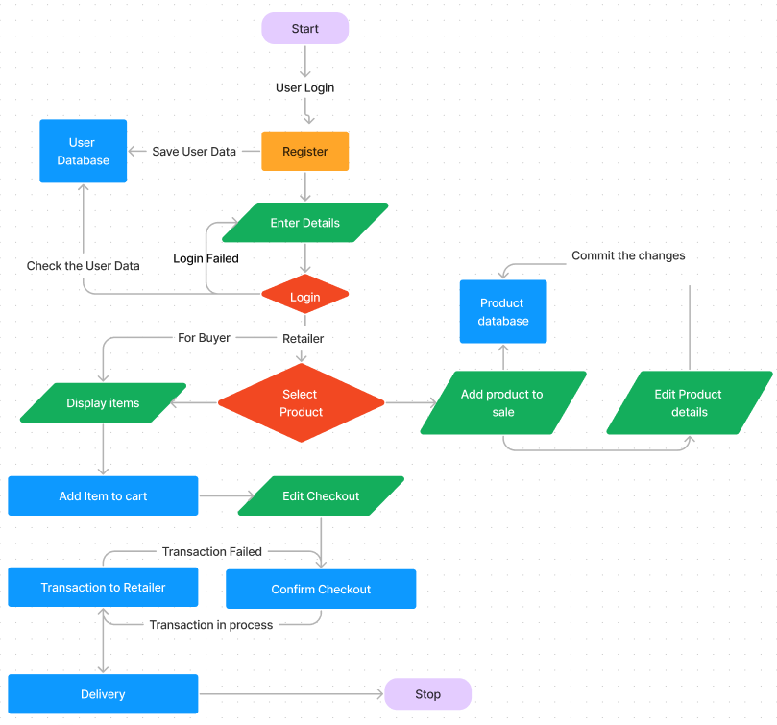

**2.4 Use Case diagram**

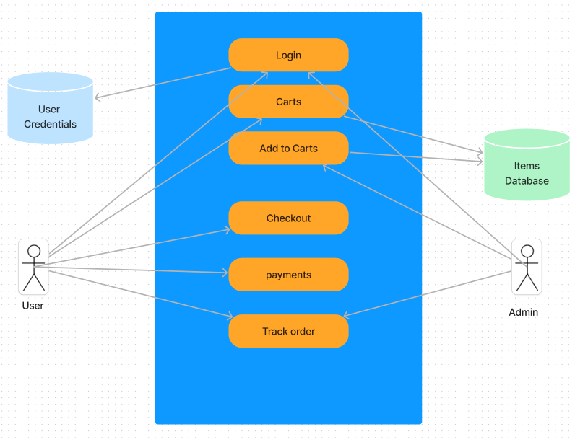

**2.5 Sequence Diagram**

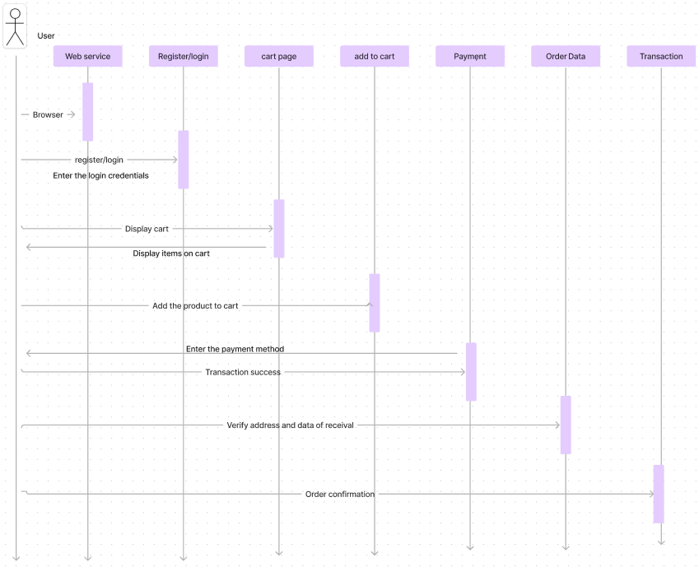

Choose item

**2.6 Class Diagram**

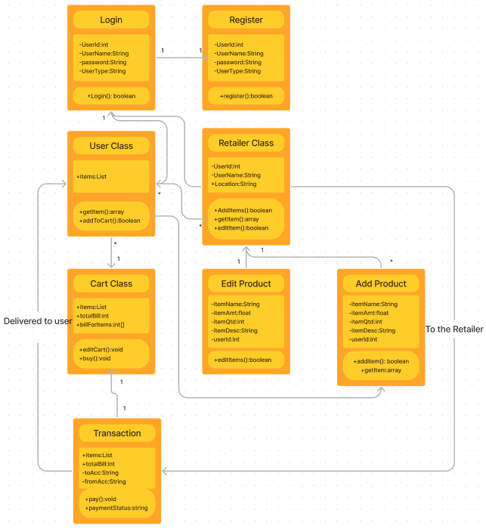

**3.Testing**

**4.Deliver for Approval**

The "Deliverables for Approval" section in the Software Requirements Specification (SRS) document outlines the documents or artifacts that need to be submitted to stakeholders for their approval before proceeding with the development process. These deliverables serve as formal sign-offs from stakeholders, indicating their agreement or acceptance of the proposed system requirements and specifications.

SRS Document: The completed SRS document, which comprehensively describes the software requirements, functionalities, interfaces, constraints, and other relevant details of the system.

Use Case Diagrams: Diagrams illustrating the various use cases and interactions between actors and the system, providing a visual representation of the system's behavior and functionality.

Sequence Diagrams: Diagrams depicting the sequence of interactions between system components or actors during a particular use case scenario, aiding in understanding the flow of operations within the system.

Database Schema: A detailed schema outlining the structure of the database, including tables, fields, relationships, and constraints, to ensure alignment with the system requirements.

Test Plan: A plan detailing the approach, resources, and schedule for testing the system to ensure that it meets the specified requirements and functions correctly.

Risk Assessment: An assessment of potential risks and challenges associated with the project, along with mitigation strategies to address them, helping stakeholders understand and manage project risks effectively.